**Data analysis report of Walmart data**

**Below are the summary of sample data for analysis**

1. There are 77186 data points for analysis.
2. Different trip types are 3 in number (values are 7,25,38)
3. Shopping has been done on all 7 days of week.
4. There are 64 different department description.
5. There are distinct 28692 UPC and 3616 Finelinenumber.
6. 1 department description can have more than 1 finelinenumber and

1 finelinenumber can have more than 1 UPC.

Observations :

1. Trip type 7 has maximum footfall of customers at 46% followed by 25 @ 30% and then 38 at 24%.

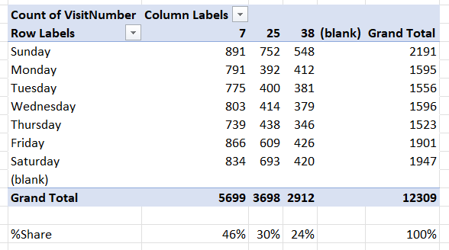

1. Trip type 7 has almost similar number of customers every day.
2. Trip type 25 and 38 has maximum footfall on Fri, Sat and Sun other days are bit lesser count.
3. Department **GROCERY DRY GOODS, DAIRY, DSD GROCERY** has highest number of footfall on daily basis.

